Subject: Programming with Java
ASSIGNMENT No : 15
TITLE :Write a Java program to demonstrate exception handling using finally, throw, and throws.

Name: Avdhoot Mohite Class: CSE A3
PRN: 25070122056 Batch:25-29

Problem Statement
Write a Java program to demonstrate exception handling using finally, throw, and throws.
Learning Objectives
To implement finally, throw, and throws for effective exception management.
Theory
The finally block always executes regardless of whether an exception occurs, making it suitable for resource cleanup. The throw keyword explicitly generates an exception, while throws declares exceptions that a method may pass to its caller. These mechanisms improve structured error handling and application stability.
Outcome
After completing this experiment, we learned how to handle exceptions in Java using finally, throw, and throws. We understood how the finally block is used for cleanup activities, how throw generates exceptions explicitly, and how throws passes exceptions to the calling method. This experiment improved our understanding of structured exception handling and program reliability.
Conclusion
The experiment successfully demonstrated the use of finally, throw, and throws in Java exception handling. These mechanisms help detect and manage runtime errors effectively, ensure proper resource management, and improve the stability, reliability, and maintainability of Java applications.
Exercise
1.Create a Login program that throws an exception for invalid password and uses finally block.
Code:

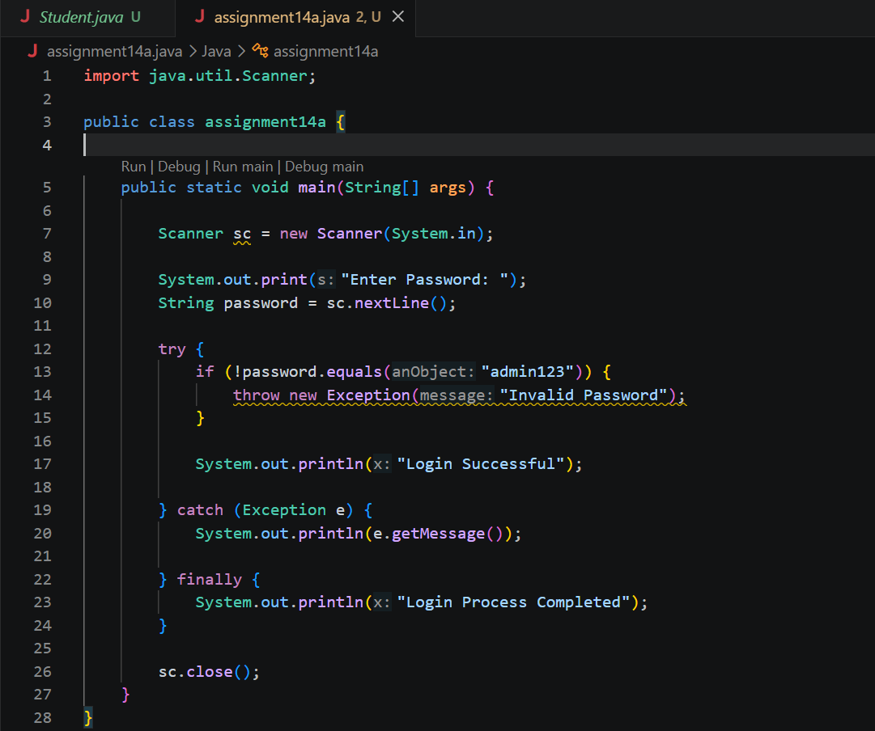
Output:
Case1:
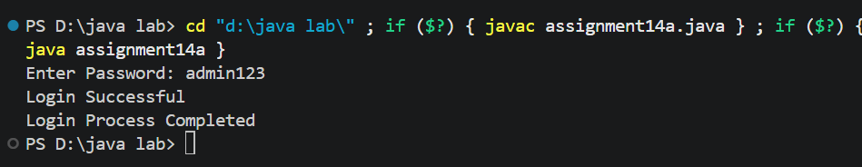

Case 2:
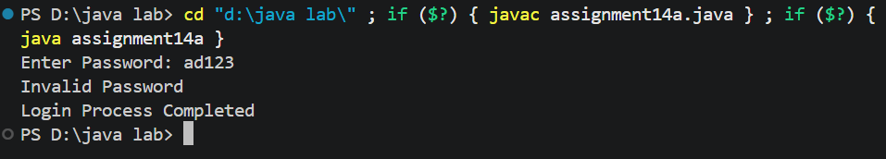

2.Create an ATM PIN Verification program that throws an exception for an invalid PIN entered by the user and uses a finally block to display a message indicating that the verification process has completed.
Code:
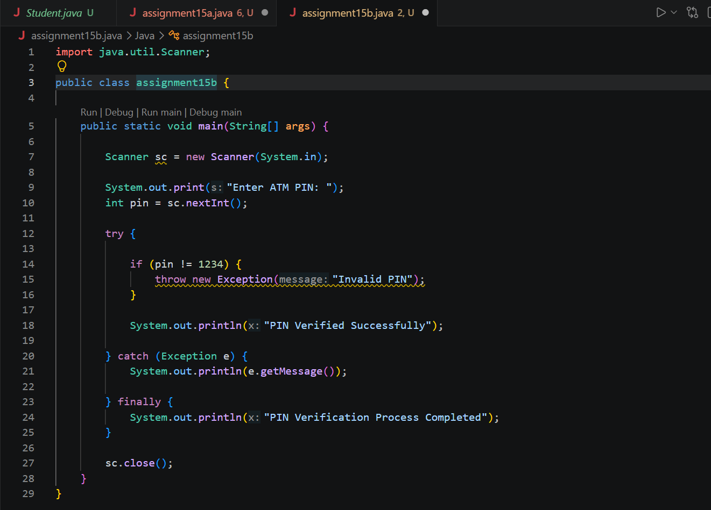
Output
